**I downloaded data from Amazon and used it to create a dashboard in Power BI**

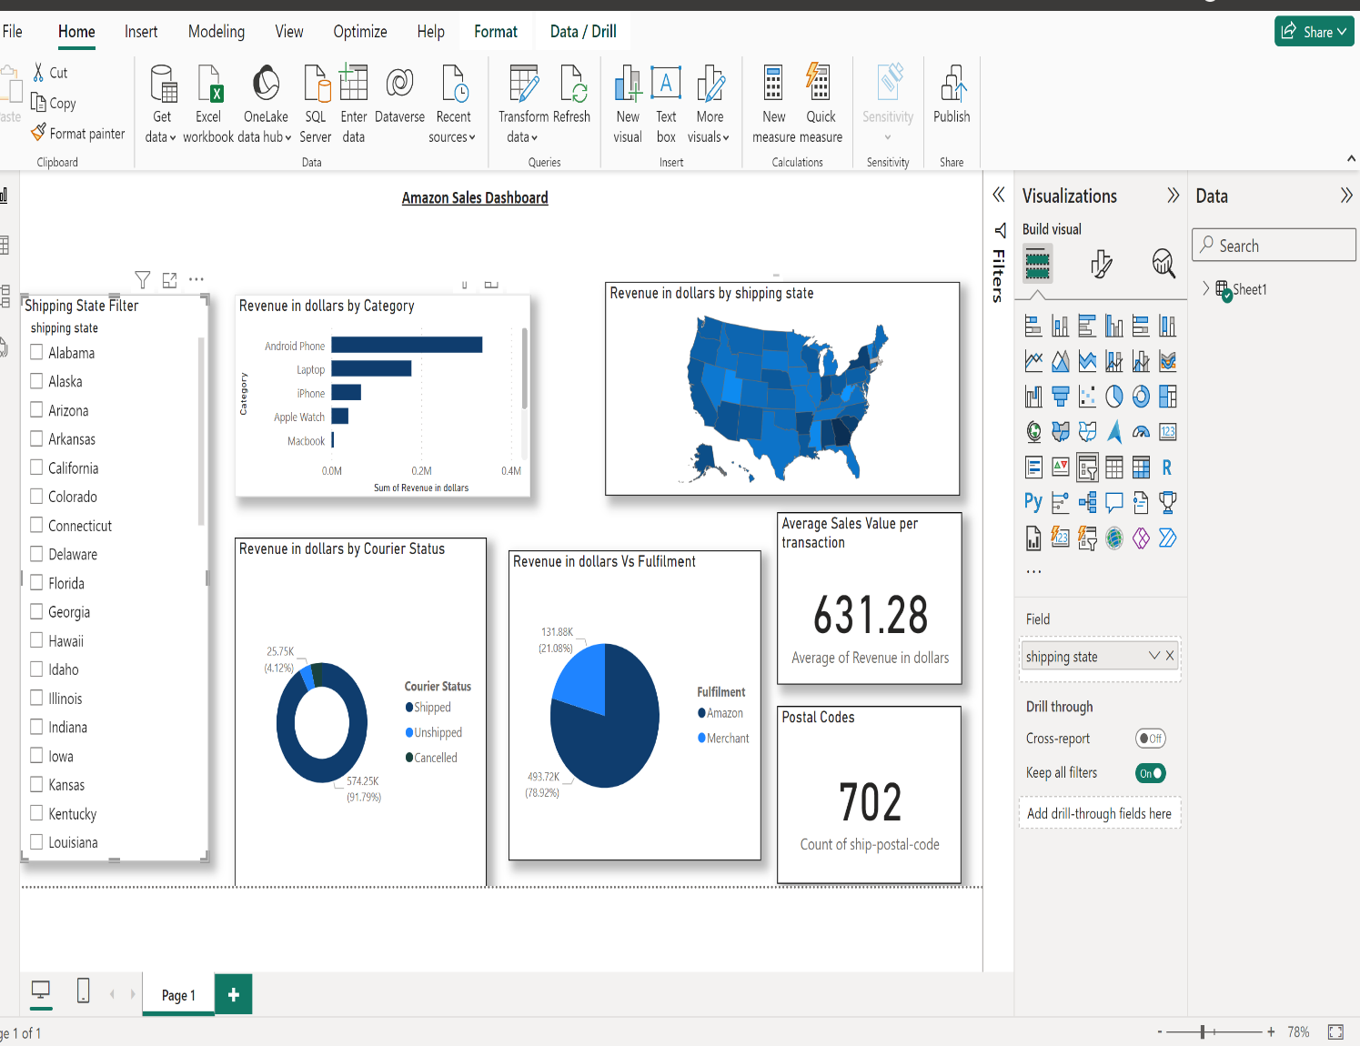

**Yahoo Finance Stock**

Yahoo Finance is a popular financial news and data platform that provides comprehensive information on stocks, mutual funds, ETFs, cryptocurrencies, and other financial instruments. It offers real-time and historical data, financial news, analysis, and tools for personal finance management. Here's an overview of Yahoo Finance's stock-related services along with some relevant data:

**Key Features of Yahoo Finance**

**Real-Time Stock Quotes**

Provides real-time stock quotes for major exchanges, including the NYSE, NASDAQ, and AMEX.

Users can track the latest price movements of individual stocks.

**Historical Dat**

Offers historical stock prices and performance data, which can be used for analysis and research.

Historical data spans several decades, allowing for in-depth long-term analysis.

**News and Analysis**

Aggregates financial news from various sources, providing timely updates on market developments.

Offers in-house analysis and articles from financial experts.

**Charts and Graphs**

Provides interactive charts and graphs that can be customized to show various technical indicators and overlays.

Users can compare the performance of multiple stocks or indices.

**Stock Screeners**

Offers stock screeners that allow users to filter stocks based on various criteria such as market capitalization, P/E ratio, dividend yield, and more.

Screeners can be customized to meet specific investment strategies.

**Portfolio Management**

Users can create and track their own investment portfolios.

Offers tools to monitor portfolio performance, track gains/losses, and receive alerts for significant events.

**Financial Statements**

Provides access to detailed financial statements, including income statements, balance sheets, and cash flow statements.

Users can review key financial ratios and metrics.

**Research Reports**

Offers access to analyst research reports and stock ratings.

Users can view consensus ratings and price targets from multiple analysts.

**Data and Statistics**

**User Base**

Yahoo Finance has millions of active users, making it one of the most visited financial websites globally.

It attracts a diverse audience, including individual investors, financial advisors, and professional traders.

**Market Coverage**

Covers a wide range of markets, including U.S. and international stocks.

Provides data on thousands of publicly traded companies.

**Mobile Accessibility**

Yahoo Finance offers a mobile app available on both iOS and Android platforms, allowing users to access financial data on the go.

The app has millions of downloads and high user ratings, reflecting its popularity and usability.

**Usage and Trends**

**Retail Investor Popularity**

Yahoo Finance is particularly popular among retail investors who use it for its ease of access and comprehensive data.

**Integration with Brokerage Accounts**

Users can link their brokerage accounts to Yahoo Finance for seamless tracking and management of their investments.

**Educational Resources**

Provides educational content and resources for novice investors, including articles, videos, and tutorials on various investment topics.

Yahoo Finance serves as a vital resource for investors seeking comprehensive financial information and tools for analyzing and tracking stock market performance. Its wide range of features and user-friendly interface make it a go-to platform for both new and experienced investors.